TWITTER SENTIMENTAL ANALYSIS:

Naïve Bayes Algorithm is used.

TWEETS –REAL TIME TWEET :

Tweets are fetched in real time.Tweepy package is used and Oauth Handler method is used for fetching real time tweets.

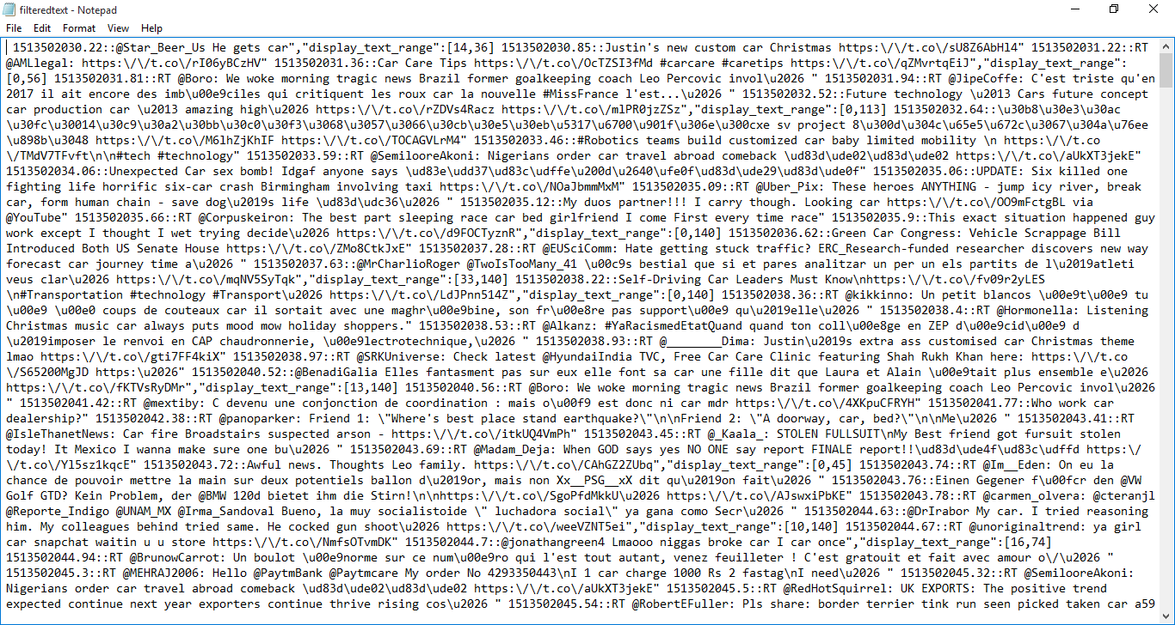

STORING IN FILES:-

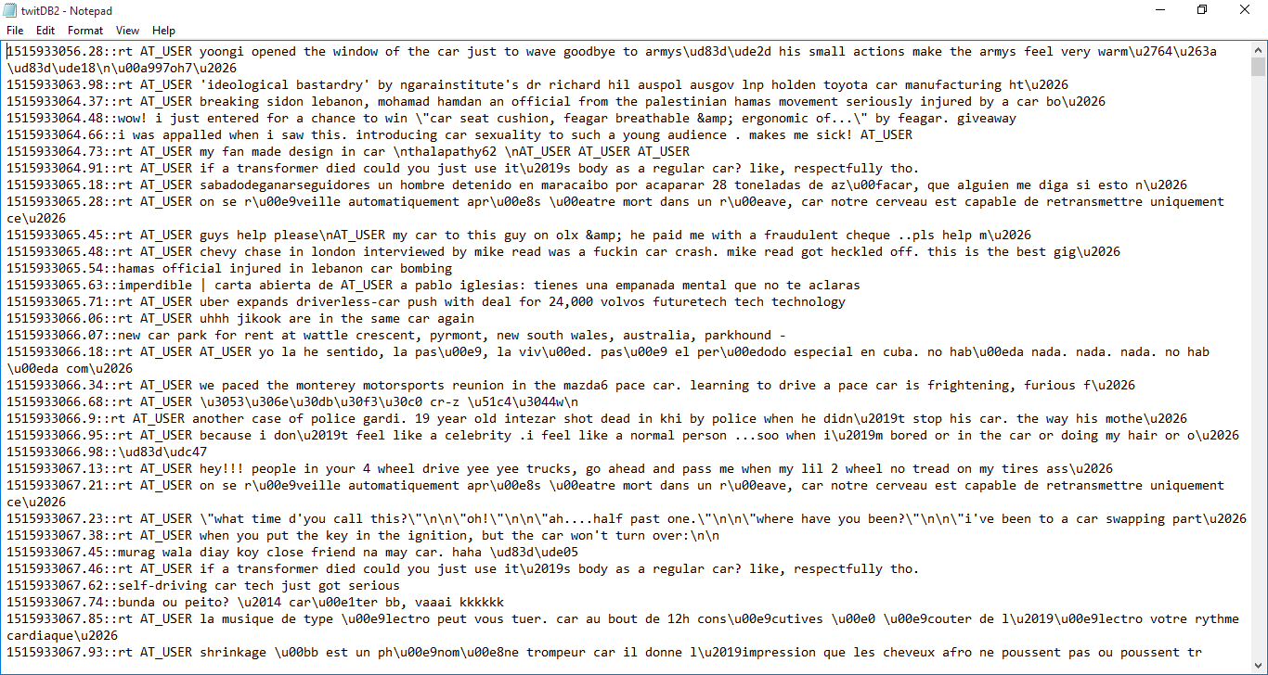

**AFTER PREPROCESSING OF TWEETS:**

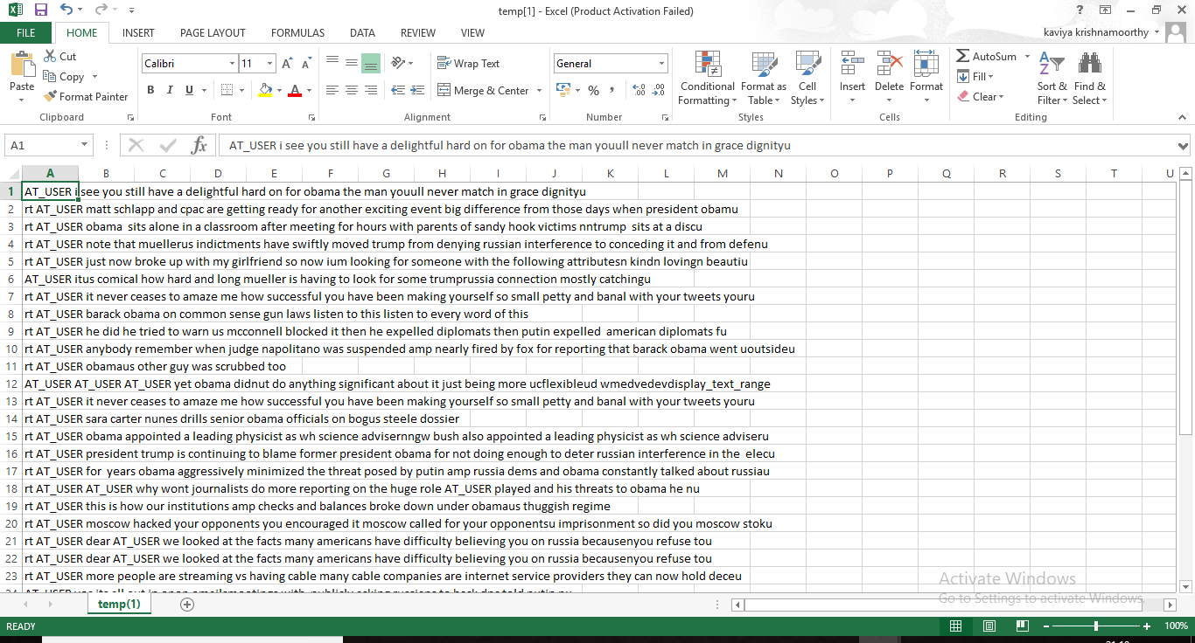

**APPLYING NAÏVE BAYES ALGORITHM TO CALCULATE THE PROBABILITY OF TWEETS USING TWITTER CORPUS DATASET:**

